**External Practical**

**AIM:**

Write a program in cloudsim using NetBeans IDE to create a six datacenters with six hosts and run cloudlets of six users on them.

**CODE:**

package org.cloudbus.cloudsim.examples;

import java.text.DecimalFormat;

import java.util.ArrayList;

import java.util.Calendar;

import java.util.LinkedList;

import java.util.List;

import org.cloudbus.cloudsim.Cloudlet;

import org.cloudbus.cloudsim.CloudletSchedulerTimeShared;

import org.cloudbus.cloudsim.Datacenter;

import org.cloudbus.cloudsim.DatacenterBroker;

import org.cloudbus.cloudsim.DatacenterCharacteristics;

import org.cloudbus.cloudsim.Host;

import org.cloudbus.cloudsim.Log;

import org.cloudbus.cloudsim.Pe;

import org.cloudbus.cloudsim.Storage;

import org.cloudbus.cloudsim.UtilizationModel;

import org.cloudbus.cloudsim.UtilizationModelFull;

import org.cloudbus.cloudsim.Vm;

import org.cloudbus.cloudsim.VmAllocationPolicySimple;

import org.cloudbus.cloudsim.VmSchedulerSpaceShared;

import org.cloudbus.cloudsim.VmSchedulerTimeShared;

import org.cloudbus.cloudsim.core.CloudSim;

import org.cloudbus.cloudsim.provisioners.BwProvisionerSimple;

import org.cloudbus.cloudsim.provisioners.PeProvisionerSimple;

import org.cloudbus.cloudsim.provisioners.RamProvisionerSimple;

public class 18DCS007{

/** The cloudlet list. */

private static List<Cloudlet> cloudletList1;

private static List<Cloudlet> cloudletList2;

private static List<Cloudlet> cloudletList3;

private static List<Cloudlet> cloudletList4;

private static List<Cloudlet> cloudletList5;

private static List<Cloudlet> cloudletList6;

/** The vmlist. */

private static List<Vm> vmlist1;

private static List<Vm> vmlist2;

private static List<Vm> vmlist3;

private static List<Vm> vmlist4;

private static List<Vm> vmlist5;

private static List<Vm> vmlist6;

/**

* Creates main() to run this example

*/

public static void main(String[] args) {

Log.printLine("Starting CloudSimExample4...");

try {

// First step: Initialize the CloudSim package. It should be called

// before creating any entities.

int num_user = 6; // number of cloud users

Calendar calendar = Calendar.getInstance();

boolean trace_flag = false; // mean trace events

// Initialize the GridSim library

CloudSim.init(num_user, calendar, trace_flag);

// Second step: Create Datacenters

//Datacenters are the resource providers in CloudSim. We need at list one of them to run a CloudSim simulation

@SuppressWarnings("unused")

Datacenter datacenter0 = createDatacenter("Datacenter_0");

@SuppressWarnings("unused")

Datacenter datacenter1 = createDatacenter("Datacenter_1");

@SuppressWarnings("unused")

Datacenter datacenter2 = createDatacenter("Datacenter_2");

@SuppressWarnings("unused")

Datacenter datacenter3 = createDatacenter("Datacenter_3");

@SuppressWarnings("unused")

Datacenter datacenter4 = createDatacenter("Datacenter_4");

@SuppressWarnings("unused")

Datacenter datacenter5 = createDatacenter("Datacenter_5");

//Third step: Create Brokers

DatacenterBroker broker1 = createBroker();

int brokerId1 = broker1.getId();

DatacenterBroker broker2 = createBroker();

int brokerId2 = broker2.getId();

//Third step: Create Brokers

DatacenterBroker broker3 = createBroker();

int brokerId3 = broker3.getId();

DatacenterBroker broker4 = createBroker();

int brokerId4 = broker4.getId();

//Third step: Create Brokers

DatacenterBroker broker5 = createBroker();

int brokerId5 = broker5.getId();

DatacenterBroker broker6 = createBroker();

int brokerId6 = broker6.getId();

//Fourth step: Create one virtual machine

vmlist1 = new ArrayList<Vm>();

vmlist2 = new ArrayList<Vm>();

vmlist3 = new ArrayList<Vm>();

vmlist4 = new ArrayList<Vm>();

vmlist5 = new ArrayList<Vm>();

vmlist6 = new ArrayList<Vm>();

//VM description

int vmid = 0;

int mips = 250;

long size = 10000; //image size (MB)

int ram = 512; //vm memory (MB)

long bw = 1000;

int pesNumber = 1; //number of cpus

String vmm = "Xen"; //VMM name

//create two VMs

Vm vm1 = new Vm(vmid, brokerId1, mips, pesNumber, ram, bw, size, vmm, new CloudletSchedulerTimeShared());

vmid++;

Vm vm2 = new Vm(vmid, brokerId2, mips, pesNumber, ram, bw, size, vmm, new CloudletSchedulerTimeShared());

vmid++;

Vm vm3 = new Vm(vmid, brokerId3, mips, pesNumber, ram, bw, size, vmm, new CloudletSchedulerTimeShared());

vmid++;

Vm vm4 = new Vm(vmid, brokerId4, mips, pesNumber, ram, bw, size, vmm, new CloudletSchedulerTimeShared());

vmid++;

Vm vm5 = new Vm(vmid, brokerId5, mips, pesNumber, ram, bw, size, vmm, new CloudletSchedulerTimeShared());

vmid++;

Vm vm6 = new Vm(vmid, brokerId6, mips, pesNumber, ram, bw, size, vmm, new CloudletSchedulerTimeShared());

//add the VMs to the vmList

vmlist1.add(vm1);

vmlist2.add(vm2);

vmlist3.add(vm3);

vmlist4.add(vm4);

vmlist5.add(vm5);

vmlist6.add(vm6);

//submit vm list to the broker

broker1.submitVmList(vmlist1);

broker2.submitVmList(vmlist2);

broker3.submitVmList(vmlist3);

broker4.submitVmList(vmlist4);

broker5.submitVmList(vmlist5);

broker6.submitVmList(vmlist6);

//Fifth step: Create two Cloudlets

cloudletList1 = new ArrayList<Cloudlet>();

cloudletList2 = new ArrayList<Cloudlet>();

cloudletList3 = new ArrayList<Cloudlet>();

cloudletList4 = new ArrayList<Cloudlet>();

cloudletList5 = new ArrayList<Cloudlet>();

cloudletList6 = new ArrayList<Cloudlet>();

//Cloudlet properties

int id = 0;

long length = 40000;

long fileSize = 300;

long outputSize = 300;

UtilizationModel utilizationModel = new UtilizationModelFull();

Cloudlet cloudlet1 = new Cloudlet(id, length, pesNumber, fileSize, outputSize, utilizationModel, utilizationModel, utilizationModel);

cloudlet1.setUserId(brokerId1);

id++;

Cloudlet cloudlet2 = new Cloudlet(id, length, pesNumber, fileSize, outputSize, utilizationModel, utilizationModel, utilizationModel);

cloudlet2.setUserId(brokerId2);

id++;

Cloudlet cloudlet3 = new Cloudlet(id, length, pesNumber, fileSize, outputSize, utilizationModel, utilizationModel, utilizationModel);

cloudlet3.setUserId(brokerId3);

id++;

Cloudlet cloudlet4 = new Cloudlet(id, length, pesNumber, fileSize, outputSize, utilizationModel, utilizationModel, utilizationModel);

cloudlet4.setUserId(brokerId4);

id++;

Cloudlet cloudlet5 = new Cloudlet(id, length, pesNumber, fileSize, outputSize, utilizationModel, utilizationModel, utilizationModel);

cloudlet5.setUserId(brokerId5);

id++;

Cloudlet cloudlet6 = new Cloudlet(id, length, pesNumber, fileSize, outputSize, utilizationModel, utilizationModel, utilizationModel);

cloudlet6.setUserId(brokerId6);

//add the cloudlets to the list

cloudletList1.add(cloudlet1);

cloudletList2.add(cloudlet2);

cloudletList3.add(cloudlet3);

cloudletList4.add(cloudlet4);

cloudletList5.add(cloudlet5);

cloudletList6.add(cloudlet6);

//submit cloudlet list to the broker

broker1.submitCloudletList(cloudletList1);

broker2.submitCloudletList(cloudletList2);

broker3.submitCloudletList(cloudletList3);

broker4.submitCloudletList(cloudletList4);

broker5.submitCloudletList(cloudletList5);

broker6.submitCloudletList(cloudletList6);

//bind the cloudlets to the vms. This way, the broker

// will submit the bound cloudlets only to the specific VM

broker1.bindCloudletToVm(cloudlet1.getCloudletId(),vm1.getId());

broker2.bindCloudletToVm(cloudlet2.getCloudletId(),vm2.getId());

broker3.bindCloudletToVm(cloudlet3.getCloudletId(),vm3.getId());

broker4.bindCloudletToVm(cloudlet4.getCloudletId(),vm4.getId());

broker5.bindCloudletToVm(cloudlet5.getCloudletId(),vm5.getId());

broker6.bindCloudletToVm(cloudlet6.getCloudletId(),vm6.getId());

// Sixth step: Starts the simulation

CloudSim.startSimulation();

// Final step: Print results when simulation is over

List<Cloudlet> newList1 = broker1.getCloudletReceivedList();

List<Cloudlet> newList2 = broker2.getCloudletReceivedList();

List<Cloudlet> newList3 = broker3.getCloudletReceivedList();

List<Cloudlet> newList4 = broker4.getCloudletReceivedList();

List<Cloudlet> newList5 = broker5.getCloudletReceivedList();

List<Cloudlet> newList6 = broker6.getCloudletReceivedList();

CloudSim.stopSimulation();

printCloudletList(newList1);

printCloudletList(newList2);

printCloudletList(newList3);

printCloudletList(newList4);

printCloudletList(newList5);

printCloudletList(newList6);

Log.printLine("");

Log.printLine("18DCS007 | RUDRA BARAD");

Log.printLine("");

Log.printLine("CloudSimExample4 finished!");

}

catch (Exception e) {

e.printStackTrace();

Log.printLine("The simulation has been terminated due to an unexpected error");

}

}

private static Datacenter createDatacenter(String name){

// Here are the steps needed to create a PowerDatacenter:

// 1. We need to create a list to store

// our machine

List<Host> hostList = new ArrayList<Host>();

// 2. A Machine contains one or more PEs or CPUs/Cores.

// In this example, it will have only one core.

List<Pe> peList = new ArrayList<Pe>();

int mips = 1000;

// 3. Create PEs and add these into a list.

peList.add(new Pe(0, new PeProvisionerSimple(mips))); // need to store Pe id and MIPS Rating

//4. Create Host with its id and list of PEs and add them to the list of machines

int hostId=0;

int ram = 2048; //host memory (MB)

long storage = 1000000; //host storage

int bw = 10000;

//in this example, the VMAllocatonPolicy in use is SpaceShared. It means that only one VM

//is allowed to run on each Pe. As each Host has only one Pe, only one VM can run on each Host.

hostList.add(

new Host(

hostId,

new RamProvisionerSimple(ram),

new BwProvisionerSimple(bw),

storage,

peList,

new VmSchedulerSpaceShared(peList)

)

); // This is our first machine

// 5. Create a DatacenterCharacteristics object that stores the

// properties of a data center: architecture, OS, list of

// Machines, allocation policy: time- or space-shared, time zone

// and its price (G$/Pe time unit).

String arch = "x86"; // system architecture

String os = "Linux"; // operating system

String vmm = "Xen";

double time_zone = 10.0; // time zone this resource located

double cost = 3.0; // the cost of using processing in this resource

double costPerMem = 0.05; // the cost of using memory in this resource

double costPerStorage = 0.001; // the cost of using storage in this resource

double costPerBw = 0.0; // the cost of using bw in this resource

LinkedList<Storage> storageList = new LinkedList<Storage>(); //we are not adding SAN devices by now

DatacenterCharacteristics characteristics = new DatacenterCharacteristics(

arch, os, vmm, hostList, time_zone, cost, costPerMem, costPerStorage, costPerBw);

// 6. Finally, we need to create a PowerDatacenter object.

Datacenter datacenter = null;

try {

datacenter = new Datacenter(name, characteristics, new VmAllocationPolicySimple(hostList), storageList, 0);

} catch (Exception e) {

e.printStackTrace();

}

return datacenter;

}

//We strongly encourage users to develop their own broker policies, to submit vms and cloudlets according

//to the specific rules of the simulated scenario

private static DatacenterBroker createBroker(){

DatacenterBroker broker = null;

try {

broker = new DatacenterBroker("Broker");

} catch (Exception e) {

e.printStackTrace();

return null;

}

return broker;

}

/**

* Prints the Cloudlet objects

* @param list list of Cloudlets

*/

private static void printCloudletList(List<Cloudlet> list) {

int size = list.size();

Cloudlet cloudlet;

String indent = " ";

Log.printLine();

Log.printLine("========== OUTPUT ==========");

Log.printLine("Cloudlet ID" + indent + "STATUS" + indent +

"Data center ID" + indent + "VM ID" + indent + "Time" + indent + "Start Time" + indent + "Finish Time");

DecimalFormat dft = new DecimalFormat("###.##");

for (int i = 0; i < size; i++) {

cloudlet = list.get(i);

Log.print(indent + cloudlet.getCloudletId() + indent + indent);

if (cloudlet.getCloudletStatus() == Cloudlet.SUCCESS){

Log.print("SUCCESS");

Log.printLine( indent + indent + cloudlet.getResourceId() + indent + indent + indent + cloudlet.getVmId() +

indent + indent + dft.format(cloudlet.getActualCPUTime()) + indent + indent + dft.format(cloudlet.getExecStartTime())+

indent + indent + dft.format(cloudlet.getFinishTime()));

}

}

}

}

**OUTPUT**

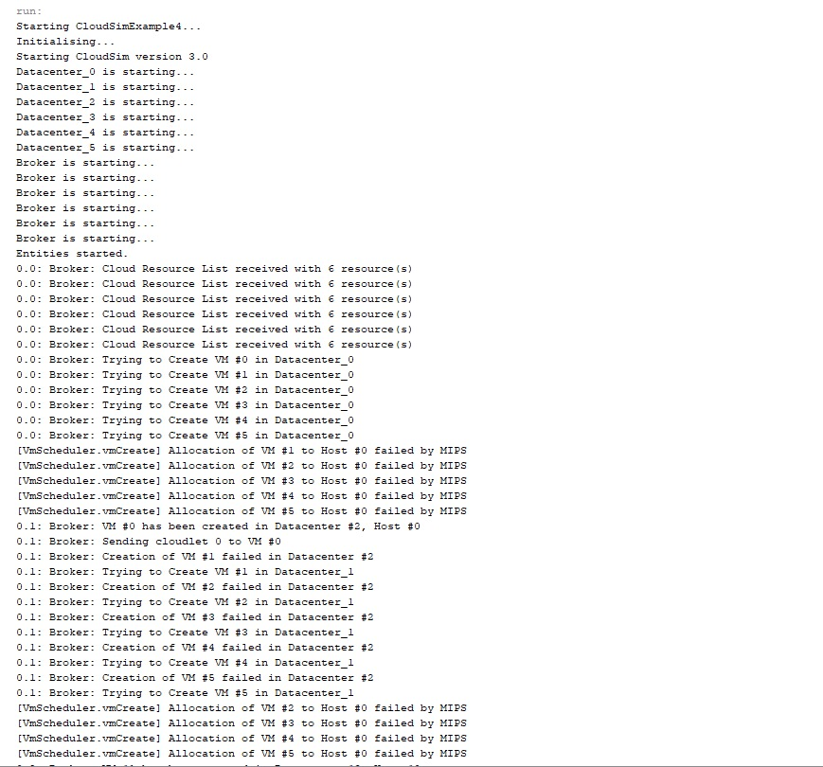

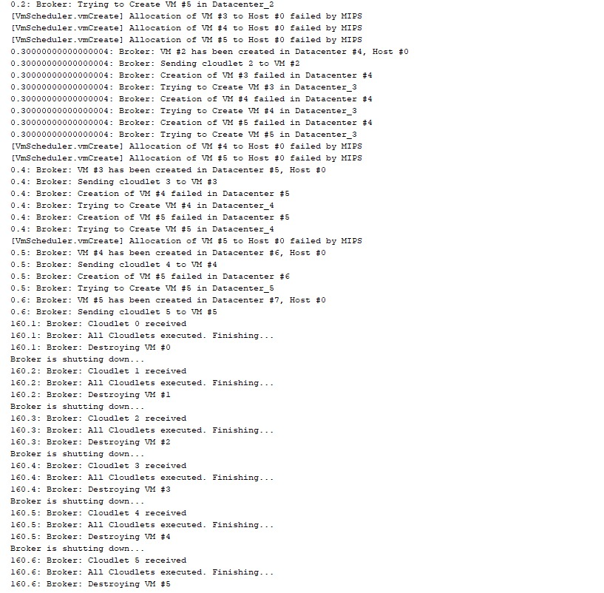

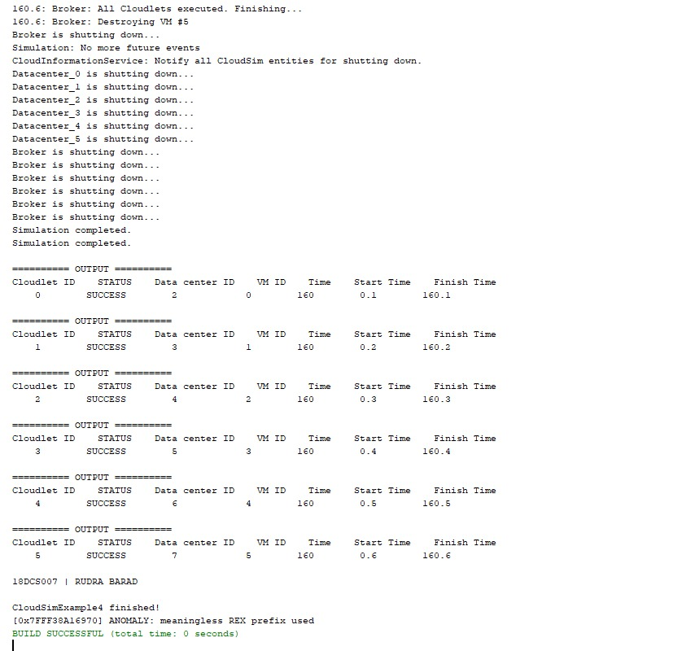

**CONCLUSION**

Successfully completed the given practical.